**Displaying a List of Items Using the ListView in Android**

ListView in Android :

In a Android, [ListView](http://developer.android.com/guide/topics/ui/layout/listview.html) is arranges components or items  in a vertical scrollable list. If you have a long list of items that you simply want to show to the user, the [ListView](http://developer.android.com/guide/topics/ui/layout/listview.html) view is the answer. This example demonstrates the way to use the [ListView](http://developer.android.com/guide/topics/ui/layout/listview.html) to show a listing of items contained within an array.

[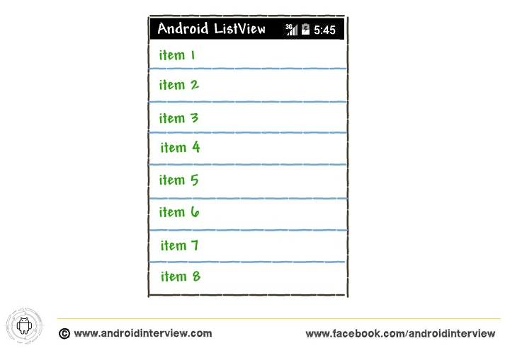](http://i0.wp.com/www.androidinterview.com/wp-content/uploads/2014/07/android-listview-example.png)

*Note : This example (Project) is developed in Eclipse Version Kepler, tested on Android 4.4.2 (KitKat Version) and SDK build-tools 22.6.3*

Solution Stuff :

In Android, use the ListView, use the <ListView> element and put it into your UI file and use “[android.widget.ListView](http://developer.android.com/reference/android/widget/ListView.html)” class to render a ListView.

Complete Code :

1. Open “**res/layout/activity_main.xml**” file. To use the “ListView ” element and put it into your UI file, such as the*activity_main.xml* file:

*File : res/layout/activity_main.xml*

XHTML

|  |  |
| --- | --- |
| 1  2  3  4  5  6  7  8  9  10  11  12 | <RelativeLayout xmlns:android="http://schemas.android.com/apk/res/android"      xmlns:tools="http://schemas.android.com/tools"      android:layout_width="match_parent"      android:layout_height="match_parent"      tools:context="${packageName}.${activityClass}" >    <ListView  android:id="@+id/android:list"  android:layout_width="fill_parent"  android:layout_height="fill_parent" />    </RelativeLayout> |

2. Open “**MainAcitvity.class**” file and add following JAVA code.

In the activity, extend the ListActivity base class and use the setListAdapter() method to bind the ListView to an ArrayAdapter object (which in turn loads the string array). You specify the type of ListView you want by specifying the android.R.layout.simple_list_item_1 constant, which is able to simply show a listing of items inside the ListView:

*File : src/packagename/MainActivity.class*

Java

|  |  |
| --- | --- |
| 1  2  3  4  5  6  7  8  9  10  11  12  13  14  15  16  17  18  19  20  21  22  23  24  25  26  27  28  29  30  31  32  33  34  35  36  37  38  39  40 | package androidinterview.com.simple.listview;    import android.app.ListActivity;  import android.os.Bundle;  import android.view.View;  import android.widget.ArrayAdapter;  import android.widget.ListView;  import android.widget.Toast;    public class MainActivity extends ListActivity {    String[] city = {  "Bangalore",  "Chennai",  "Mumbai",  "Pune",  "Delhi",  "Jabalpur",  "Indore",  "Ranchi",  "Hyderabad",  "Ahmedabad",  "Kolkata"  };    *@Override*  protected void onCreate(Bundle savedInstanceState) {  super.onCreate(savedInstanceState);  setContentView(R.layout.activity_main);    //Listview adapter  setListAdapter(new ArrayAdapter<String>(this,  android.R.layout.simple_list_item_1,city));  }  public void onListItemClick(ListView parent, View v,  int position, long id) {  Toast.makeText(this, "You have selected city : " + city[position],  Toast.LENGTH_LONG).show();  }  } |

The onListItemClick() method is that the callback method used once the user has selected  an item inside the ListView. The second argument indicates the index of the items inside the ListView that was selected . using this information, you’ll reference it against your array and obtain the name of the item selected .

**Figure shows what the ListView looks in Android emulator.**

[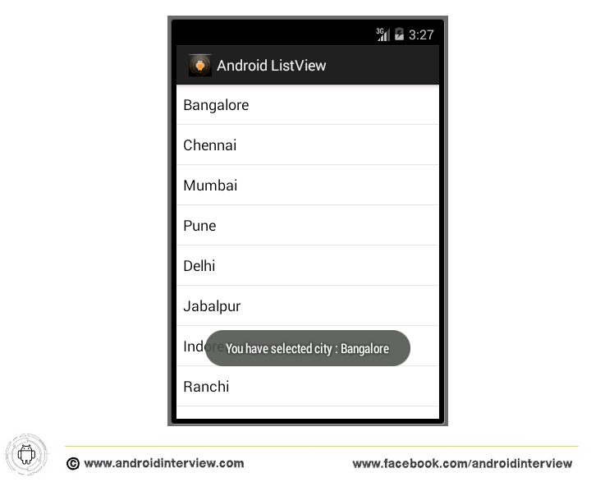](http://i0.wp.com/www.androidinterview.com/wp-content/uploads/2014/07/android-listview-example1.png)

Download Android ListView example Source code :

|  |
| --- |
| Icon  **Android ListView example Source code**3.95 MB  [**Android ListView example Download**](http://www.androidinterview.com/android-simple-listiview-example/) |